# Changing the Scale

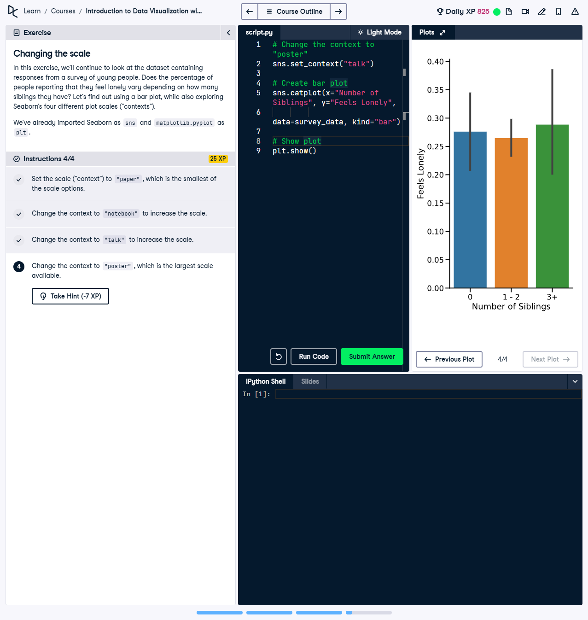

Figure 1: Screenshot showing the bar plot and solution context.

## Question

In this exercise, we will continue to look at the dataset containing responses from a survey of young people.  
Does the percentage of people reporting that they feel lonely vary depending on how many siblings they have?   
Let's find out using a bar plot while also exploring Seaborn's four different plot scale contexts.  
  
Instructions:  
1. Set the scale context to "paper", which is the smallest of the scale options.  
2. Change the context to "notebook" to increase the scale.  
3. Change the context to "talk" to increase the scale further.  
4. Change the context to "poster", which is the largest scale available.

### Question Explanation

This question involves using Seaborn's context scaling to adjust the visualization's appearance. The task requires setting various context options ("paper," "notebook," "talk," "poster") to observe their effect on bar plots for data visualization purposes.

## Corrected Code Solution

# Change the context to "poster"  
sns.set_context("talk")  
  
# Create bar plot  
sns.catplot(x="Number of Siblings", y="Feels Lonely",  
 data=survey_data, kind="bar")  
  
# Show plot  
plt.show()

### Answer Explanation

The solution correctly sets the Seaborn context to "talk" for increased visualization scaling, close to presentation quality. A bar plot is created using sns.catplot(), specifying the x-axis ("Number of Siblings"), y-axis ("Feels Lonely"), and dataset ("survey_data"). The plt.show() command renders the final plot.